Focus Actions for 21/22
1. Develop, implement and evaluate the curriculum for Oracy across school.
2. For staff to be aware of what it means to develop an Oracy rich classroom and for this disciplinary knowledge to be implemented in lessons.
3. For staff to plan for Greater Depth thinking in Oracy, including DISCO questions and using feedback to move children forward.
The Curriculum in Oracy:
These skills are being encouraged in every area of our curriculum as good oracy skills can enhance every type of learning including maths and science. A key part of oracy is for children to think carefully about the language they’re using, and tailor it to their subject, purpose and audience. They are often linked with the DISCO questions, created to develop our Greater Depth level of understanding across the board. 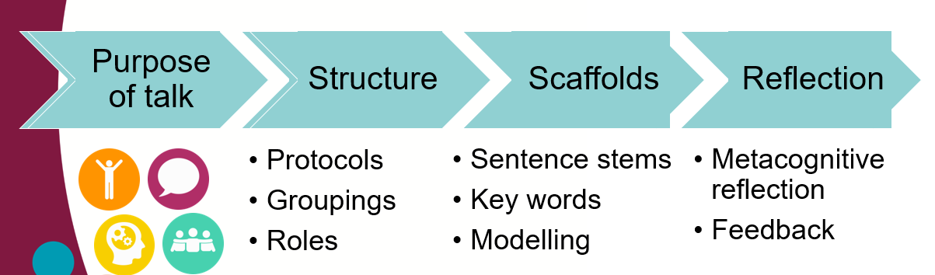

Intent:
Speaking and listening are fundamental to the teaching of English and permeates the whole curriculum – cognitively, socially and linguistically. We want our children to develop effective communication skills for the here and now and also in readiness for later life. Having recently invested in Oracy training with Voice 21 (a national charity that exists to enable teachers and schools to provide a high quality Oracy education so that all young people can find their voice for success in school and life) we are committed to building and embedding a culture of oracy throughout our curriculum.

Our aim is to enable the children to improve their levels of oracy so that they are express themselves clearly and are able to communicate effectively and confidently in front of any type of audience.

Implementation:
What does our planning include? | What approaches to Teaching and Learning do we use? | CPD
- Opportunities for Oracy embedded into every lesson.  - Sentence starters and vocabulary boxes.  - Lessons that balance opportunities for learning to talk as well as learning through talk.  - Questioning in lesson utilising approaches from “Teaching Walkthrus”.  - Peer Feedback. | Digital learning: outcomes are monitored by Oracy leads to ensure they are on track to achieve high outcomes by the end of the year.  Exceeding Expectations: Sentence Starter and Vocabulary curriculum’ to be created and used in net years planning to map progression throughout school.  Recovery: Reflect on use of Oracy skills in intervention throughout the year to see if children have met the Oracy standards. Using Oracy rich lesson plans based on exploratory talk to help children fill in any gaps from lockdown.  Adapted approaches to learning:  Early Years – Age appropriate sentence starters and vocabulary. Developing listening skills through an Oracy based lesson. Modelled activities and tailored group work.  KS1 – Age appropriate sentence starters and vocabulary. Opportunities to start debating in Teacher led activities. Roles based lessons.  KS2 – Age appropriate sentence starters and vocabulary. Depth of talking roles. Technology is linked to crate narratives and depth of speaking skills.  Diversity: Learning walks will evidence that disco questions will be in books and Ipads. Talk charter to embed class rules. | - Continuous CPD, both formal and bite size sessions in school with all staff.  - Ongoing project linked with NPQML.  - Collaborative work with National Leader in Oracy from Huntingdon Primary.  - Collaboration with Edale Rise and Transform Trust.  - Voice 21 and Think Tank sessions.
Key Resources in school:
- iPads/Computers.
- Table grouping.
- Classroom environment shows children’s learning and questioning.
- CPD and informal sessions for development.

How do we evaluate the impact of Teaching and Learning?
Evaluating is at the heart of the planning, teaching and learning cycle. Feedback given during and after lessons helps children move forward with their learning and prior learning is reviewed at the beginning of lessons. This allows teachers to address misconceptions as they teach and adapt their teaching to their class’s needs.
Over time, the impact of teaching and learning is evident from pupils’ books and teachers’ annotated plans, showing that misconceptions have been addressed and children know and understand more. Children should be able to ask and answer questions about what they have learnt and show an understanding of why this is an important thing to learn about. Lesson observations from the subject leader will show that teachers are following the curriculum and incorporating a range of effective teaching and learning strategies.

