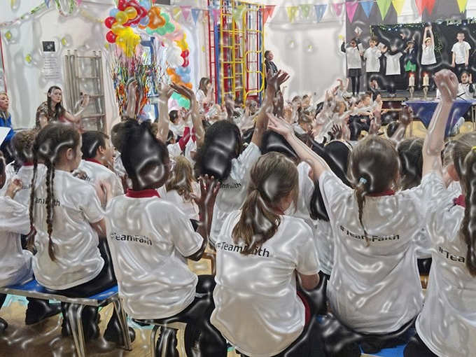



Theologically Rooted Christian Mission, Vision and Values
Our Mission
‘To Be at Our Best’

To always be at our best in our learning and spiritual journey.
Through a collective commitment to high expectations and putting our faith at the centre of all we do, not only can we ensure that no doors are closed, but that the biggest and heaviest doors are wide open and our calling is clear.

By living out our Christian values and providing rich experiences, we will have the courage to walk through those doors with resilience, confidence and excitement to be all God meant us to be.

Understanding the Heart of Our Mission
At the centre of our mission is a call to excellence—not just in academic achievement, but in our spiritual development and daily living. This mission reflects a deeply rooted theological vision that sees each person as uniquely created in the image of God, with inherent value, purpose, and potential.

Faith and Excellence: A Unified Journey
The phrase "to always be at our best in our learning and spiritual journey" highlights the dual focus of our mission: intellectual growth and spiritual formation. We believe that these two pursuits are not separate, but interconnected. To grow in knowledge without deepening in faith leaves a person incomplete. Our commitment to excellence in both spheres reflects the biblical call to love the Lord our God with all our heart, soul, mind, and strength (Mark 12:30).

Faith at the Centre
By "putting our faith at the centre of all we do," we are guided by a Christ-centred approach that informs every decision, relationship, and goal. This foundation gives meaning to our actions and unites us as a community striving for the same purpose: to live out our calling as children of God.

Opening Doors Through High Expectations
We hold "a collective commitment to high expectations" not as pressure, but as belief—belief in the God-given potential of every individual. When we expect the best, we reflect God's hope and confidence in us. This attitude removes limitations and ensures that "no doors are closed." The metaphor of opening even "the biggest and heaviest doors" speaks to our belief in divine empowerment—God makes a way where there seems to be no way (Isaiah 43:16).

Walking in Calling and Purpose
When we say "our calling is clear," we affirm that every person is created for a purpose. Through prayer, reflection, and community support, we discern this calling. Living in line with God’s purpose brings fulfilment, clarity, and direction.

Christian Values and Courage
By "living out our Christian values and providing rich experiences," we nurture a way of life grounded in love, service, integrity, compassion, and humility. These values are not abstract ideals—they are lived truths that shape our character. In doing so, we develop "the courage to walk through those doors with resilience, confidence and excitement."
Courage, in this context, is not the absence of fear but the presence of faith. It is a bold trust in God’s promises and plans, even when the journey is challenging.

Becoming All God Meant Us to Be
Ultimately, our mission invites each person to step fully into their God-given identity and destiny—to "be all God meant us to be." This is not about personal ambition, but about faithfully responding to God’s call and using our gifts for His glory and the good of others.

Conclusion
Our mission is not just a statement—it is a shared commitment to walk together in faith and learning, with hearts open to God’s leading. Rooted in theology, inspired by Scripture, and lived through community, our mission empowers us to open doors and walk boldly into the future God has prepared for us.

Our Vision:
"To Spark the Flame & Light up the World – bringing out the God-colours of the world."

Rooted in Scripture, Inspired by Christ
Our vision is deeply grounded in biblical truth and reflects the life and teaching of Jesus Christ. It speaks of purpose, transformation, and mission—inviting every member of our school community to be a light in the world and a reflection of God’s beauty, creativity, and love.

"To Spark the Flame" – Igniting Faith and Purpose
The image of a flame represents the Holy Spirit, who ignites faith in the hearts of believers (Acts 2:3-4). To “spark the flame” is to awaken that divine potential within each child—to nurture their God-given gifts, curiosity, and sense of purpose.
This part of our vision speaks to inspiration, awakening, and discipleship. We strive to create an environment where each learner feels the spark of belief—both in themselves and in something greater. Like a candle that lights another, we aim to pass on light through teaching, mentoring, and living out our faith.

"Light up the World" – Living as Christ's Light
Jesus said,
“You are the light of the world... Let your light shine before others, that they may see your good deeds and glorify your Father in heaven.” (Matthew 5:14–16)
This powerful message forms the core of our vision. As a Christian school, we encourage all pupils and staff to live in a way that reflects Christ’s light—bringing hope, justice, kindness, and truth to others.
To "light up the world" is to make a difference. It means using our learning, talents, and values not just for personal success, but to uplift and transform the lives of others, near and far. It is an outward call to serve, to lead with compassion, and to live courageously in faith.

"Bringing Out the God-Colours of the World" – Celebrating God's Creativity in Everyone
This phrase, drawn from The Message paraphrase of Matthew 5:14, points to the diversity, richness, and creativity of God’s creation. We believe every child carries a unique reflection of God—what we call their "God-colours."
These God-colours represent personality, potential, character, creativity, and calling. Our role as a school is to help each pupil discover and develop these qualities—so they not only shine individually, but also contribute vibrantly to the beauty and diversity of the wider world.
As educators and carers, we are called to recognise and nurture the image of God in every child—to help them see their own worth, and to celebrate the worth of others.

A Vision That Shapes Everything We Do
Our vision is not simply a slogan—it’s a spiritual and educational call to action. It shapes:
- How we teach – encouraging creativity, critical thinking, and curiosity
- How we relate – showing respect, empathy, and inclusion
- How we lead – with integrity, service, and humility
- How we grow – continually seeking wisdom, faith, and joy
By sparking the flame of faith, lighting up the world through action, and revealing the God-colours within each person, we live out our Christian vision every day—together, as a community of light.

Our Values: Theologically Rooted in the Life of Jesus
At the heart of our school are three core values:
To be curious, to love and respect, and to be brave.
These values are more than educational aims—they are deeply theological. They are shaped by the life, teaching, and example of Jesus Christ, and are intentionally designed to be accessible and meaningful for children in a primary school context.

1. Be Curious – Encounter Jesus
Curiosity is the starting point for learning—and for faith. In the Gospels, Jesus regularly welcomed questions, invited exploration, and encouraged those who were seeking truth. He said, “Come and see” (John 1:39) and “Ask and it will be given to you” (Matthew 7:7).
By encouraging children to be curious, we are nurturing a spiritual openness—one that invites them to explore big questions, wonder about God, and encounter Jesus for themselves. Curiosity is an invitation to relationship, not just information.

2. Love and Respect – Become Like Him
Jesus summed up his teaching with a simple but profound command: “Love God and love your neighbour” (Matthew 22:37–39). He modelled this love through his actions—caring for the outcast, honouring the overlooked, and respecting each person as made in God’s image.
In a school setting, love and respect are the foundation of healthy relationships and a strong community. When children learn to treat others with kindness and dignity, they are not just learning good manners—they are learning what it means to become like Jesus.

3. Be Brave – Do the Things He Did
Jesus lived with extraordinary courage. He challenged injustice, welcomed the outsider, forgave those who hurt him, and ultimately gave his life for others. He told his followers: “You will do the works I have been doing” (John 14:12).
To be brave is to follow that call—to stand up for what is right, to speak truth, to forgive, and to live out faith in action. In a primary school, this might look like a child standing up for a friend, admitting a mistake, or showing kindness when it’s hard. These are small but significant ways of learning to do the things Jesus did.

Why This Matters
In a Christian school, values are not just about behaviour—they are about formation. These three values offer children a simple pathway of discipleship:
- Be Curious – Grow in relationship with Jesus.
- Love and Respect – Be formed in the character of Jesus.
- Be Brave – Join in the mission of Jesus.
By rooting our values in the life of Christ, we help children (and adults) grow not just academically or socially, but spiritually—with lives shaped by faith, hope, and love.

