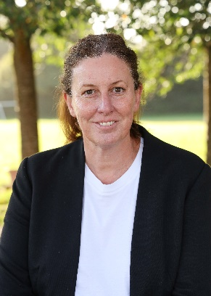 |  |  |  |  |  | 
Natalie Aldridge  Headteacher  LEAD DSL | Ben Precious  AHT  Deputy DSL | Simon Good  Deputy Headteacher  DSL | Henry Jolliffe KS2 Lead  DSL | Kate Marusiak  KS1 Lead  DSL | Abigail Todhunter  Senco  DSL | Tom McGowan  Safeguarding Governor

Safeguarding at South Wilford CE Primary School- Designated safeguarding Leads

Claire McKendrick is the Operational Safeguarding Lead for Transform Trust.
She can be contacted on 01159825090 or by e mail at
claire.McKendrick@transformtrust.co.uk

Natalie Aldridge natalie.aldridge@southwilford.nottingham.sch.uk
Ben Precious ben.precious@southwilford.nottingham.sch.uk
Abigail Todhunter abigail.todhunter@southwilford.nottingham.sch.uk
Simon Good simon.good@southwilford.nottingham.sch.uk
Kate Marusiak kate.marusiak@southwilford.nottingham.sch.uk
Henry Jolliffe henry.jolliffe@southwilford.nottingham.sch.uk
Tom McGowan tom.mcgowan@southwilford.nottingham.sch.uk



